(This sample text can be used as a base to write your manuscript. The text format is Calibri Light 11, letter size paper, 1.5 spacing, 2.5 cm margins, and continuous line numbering).

English title, centered and bold

Peter Johnson¹, George S. Stevens^{1*}, and Mary Smith-Moore²
(Each author must include full first and main last name, with complete affiliation in descending hierarchical order)

¹Institution, Faculty or Department, city, country.
²Institution, Faculty or Department, city, country.
*Corresponding author (e-mail).

ABSTRACT

The abstract is a single paragraph of no more than 250 words that includes the five parts of the manuscript: (1) An introductory sentence to state the importance of the topic or issue, (2) the main objective, (3) general description of methods, treatments, or evaluations, (4) main results expressed with values and statistical significance, and (5) the conclusion of the evaluation or analysis of the experimental results. It should not cite figures, tables, or references; equations should be avoided.

Key words: No more than six words listed in alphabetical order, which reflect the central topics of the manuscript.

INTRODUCTION

Emphasizes the importance of the research, places it in a context, presents related literature, and gives enough information to understand the authors’ hypothesis. It ends with a paragraph stating the objective of the research.

MATERIALS AND METHODS
Subtitle
There should be sufficient information to allow other researchers to repeat the experiment by clearly defining the experimental design. A clear description or a specific reference to all biological, analytical, and statistical procedures is required. All procedure modifications must be explained. Field experiments that are sensitive to interactions and where the crop environment cannot be rigorously controlled, such as crop production and yield component assays, must be repeated for time and/or space, in order to ensure representative results. Equipment and instruments used in experimental work should be mentioned by their common name and between parentheses model, brand, city, state, and country of the manufacturer.

RESULTS AND DISCUSSION

This section can be combined or separated. Results should be clear and concise, supported by tables, figures (at the end of the manuscript), and statistical analyses. Results should be analyzed in the text without repeating table or figure values. Data should be presented, including some variation indexes or significance, allowing the reader to interpret experimental results. The Discussion should clearly and precisely interpret results supported by pertinent and recent scientific literature (less than 10 years).

CONCLUSIONS

In accordance with research objectives, this section begins with a clear statement based on the results and states whether testing supports or disproves the hypothesis of the article. If the results have no implications, this fact should be mentioned. Conclusions must be based on objective data rather than author speculation, limit comments to the results and do not suggest further research. Do not use abbreviations, acronyms, or references.

Author contribution
An individual contributor may be assigned to multiple roles, and a given role may be assigned to multiple contributors.
Example: Conceptualization: F.Z-P., B.L. Methodology: F.Z-P. Software: F.Z-P. Validation: F.Z-P. Formal analysis: F.Z-P. Investigation: F.Z-P. Resources: B.L. Data curation: B.L. Writing-original draft: F.Z-P. Writing-review & editing: B.L. Visualization: F.Z-P. Supervision: B.L. Project administration: B.L. Funding acquisition: B.L. All co-authors reviewed the final version and approved the manuscript before submission.

Acknowledgements
This section must include funding institutions or organizations and corresponding grant and/or project that support the research.

Conflict of interest
Just include this item if consider pertinent.

References
Recently published articles (less than 10 years) in mainstream peer-reviewed scientific journals should be included. Research Articles should not include more than 35 references, and only published papers can be cited. For Review articles the limit is 90. ChileanJAR does not allow references In Press or just submitted. List references alphabetically. Authors are listed by surname and initial(s), separated by commas if there are more than two authors. Please note the use of commas and periods.
To allow a fast and correct publishing process please remove field codes of reference manager converting citations and bibliography to plain text.

Ergina, E.I., Zhuk, V.O. 2022. Risks and permissible rates of soil erosion in the agrolandscapes of the Crimea. p. 257-270. In Saljnikov, E., Mueller, L., Lavrishchev, A., Eulenstein, F. (eds.) Advances in understanding soil degradation. Springer, Cham, Switzerland. doi:10.1007/978-3-030-85682-3_11.
Ferré, C., Beattie, A., Feurtado, J.A. 2023. Understanding lodging in oat through root, stem, and leaf characteristics. 2023 ASA, CSSA, SSSA International Annual Meeting, St. Louis, Missouri. 29 October-1st November. ASA, CSSA and SSSA, Madison, Wisconsin, USA. Available at https://scisoc.confex.com/scisoc/2023am/meetingapp.cgi/Paper/150690.
Neocleous, D., Savvas, D., Giannothanasis, E., Ntatsi, G. 2024. Partial substitution of nitrate by chloride in fertigation recipes allows for lower nitrate input in hydroponic lettuce crops. Frontiers in Plant Science 15:1411572. doi:10.3389/fpls.2024.1411572.
Saljnikov, E., Mueller, L., Lavrishchev, A., Eulenstein, F. (eds.) 2022. Advances in understanding soil degradation. Springer, Cham, Switzerland.
Tables and Figures
Include tables and figures after References. They should be self-explanatory without reference to the text. Font must be Calibri Light. Titles should be brief and descriptive. They must be numbered following mention order. Data presented in tables should not be duplicated in graphs, and vice versa. Divisions of the graph axes should be shown with interval marks rather than with a grid over the entire graph. The numbers on both axes should be the same size and should all read horizontally.

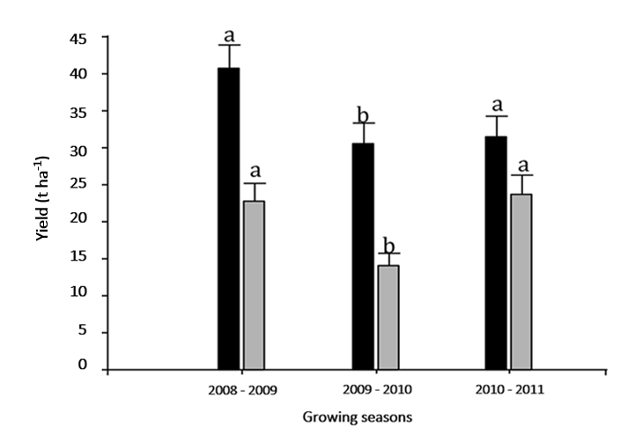
Figure 1. Total and commercial yields of ‘Williams’ pear for different growing seasons. Different letters on bars corresponding to the same response variable, total yield (black) or commercial yield (grey) indicate significant differences between growing seasons according to Tukey test (P < 0.05). Vertical bars correspond to standard error. Growing seasons n = 30.

Table 1. Effect of the stage of maturity of loquat ‘Golden Nugget’ on soluble solids, acidity, soluble solids/acidity, and pH. Distinct letters in the row indicate significant differences according to Tukey’s test (P ≤ 0.05).
Maturity stage | Soluble solids | Acidity | Soluble solids/acidity | pH
 | °Brix | g 100 mL⁻¹
Green | 4.86ª | 0.67ª | 7.44ª | 2.81ª
Color break | 7.27^{b} | 1.00^{b} | 7.49ª | 2.93ª
Yellow | 8.31^{b} | 0.95^{ab} | 8.89ª | 2.99ª
Orange | 11.80^{c} | 0.28^{c} | 49.08^{b} | 3.51^{b}

